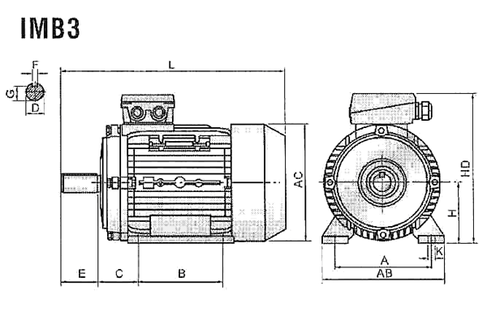
Габарит | IMB3
Габарит | A | B | C | D | E | F | G | H | K
56 | 90 | 71 | 36 | 9 | 20 | 3 | 7,2 | 56 | 5,8
63 | 100 | 80 | 40 | 11 | 23 | 4 | 8,5 | 63 | 7
71 | 112 | 90 | 45 | 14 | 30 | 5 | 11,0 | 71 | 7
80 | 125 | 100 | 50 | 19 | 40 | 6 | 15,5 | 80 | 10
90S | 140 | 100 | 56 | 24 | 50 | 8 | 20,0 | 90 | 10
90L | 140 | 125 | 56 | 24 | 50 | 8 | 20,0 | 90 | 10
100L | 160 | 140 | 63 | 28 | 60 | 8 | 24,0 | 100 | 12
112M | 190 | 140 | 70 | 28 | 60 | 8 | 24,0 | 112 | 12
132S | 216 | 140 | 89 | 38 | 80 | 10 | 33,0 | 132 | 12
132M | 216 | 178 | 89 | 38 | 80 | 10 | 33,0 | 132 | 12
160M | 254 | 210 | 108 | 43 | 110 | 12 | 37,0 | 160 | 15
160L | 254 | 254 | 108 | 42 | 110 | 12 | 37,0 | 160 | 15
180M | 279 | 241 | 121 | 48 | 110 | 14 | 42,5 | 180 | 15
180L | 279 | 279 | 121 | 48 | 110 | 14 | 42,5 | 180 | 15
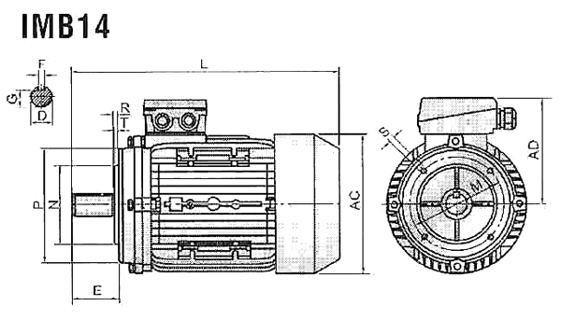
Габарит | IMB14
Габарит | M | N | P | R | S | T
56 | 65 | 50 | 80 | 0 | M5 | 2,5
63 | 75 | 60 | 90 | 0 | M5 | 2,5
71 | 85 | 70 | 105 | 0 | M6 | 2,5
80 | 100 | 80 | 120 | 0 | M6 | 3,0
90S | 115 | 95 | 140 | 0 | M8 | 3,0
90L | 115 | 95 | 140 | 0 | M8 | 3,0
100L | 130 | 110 | 160 | 0 | M8 | 3,5
112M | 130 | 110 | 160 | 0 | M8 | 3,5
132S | 165 | 130 | 200 | 0 | M10 | 4,0
132M | 165 | 130 | 200 | 0 | M10 | 4,0
160M | 215 | 180 | 250 | 0 | M12 | 4,0
160L | 215 | 180 | 250 | 0 | M12 | 4,0
180M | 265 | 230 | 300 | 0 | M15 | 4,0
180L | 265 | 230 | 300 | 0 | M15 | 4,0
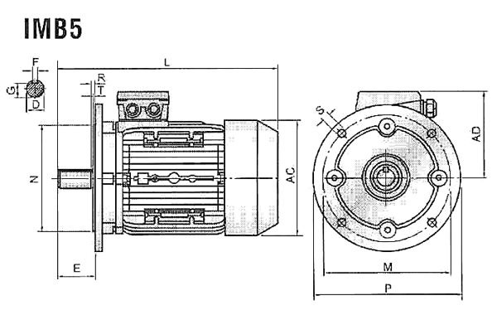
Габарит | IMB5
Габарит | M | N | P | R | S | T
56 | 100 | 80 | 120 | 0 | 7 | 3,0
63 | 115 | 95 | 140 | 0 | 10 | 3,0
71 | 130 | 110 | 160 | 0 | 10 | 3,5
80 | 165 | 130 | 200 | 0 | 12 | 3,5
90S | 165 | 130 | 200 | 0 | 12 | 3,5
90L | 165 | 130 | 200 | 0 | 12 | 3,5
100L | 215 | 180 | 250 | 0 | 15 | 4,0
112M | 215 | 180 | 250 | 0 | 15 | 4,0
132S | 265 | 230 | 300 | 0 | 15 | 4,0
132M | 265 | 230 | 300 | 0 | 15 | 4,0
160M | 300 | 250 | 350 | 0 | 15 | 5,0
160L | 300 | 250 | 350 | 0 | 15 | 5,0
180M | 300 | 250 | 350 | 0 | 19 | 5,0
180L | 300 | 250 | 350 | 0 | 19 | 5,0

Габаритные размеры
Габарит | AB | AC | AD | HD | L
56 | 110 | 120 | 110 | 155 | 195
63 | 130 | 130 | 115 | 165 | 230
71 | 145 | 145 | 125 | 185 | 255
80 | 153 | 155 | 130 | 210 | 285
90S | 173 | 175 | 136 | 226 | 330
90L | 180 | 185 | 145 | 235 | 360
100L | 205 | 215 | 170 | 255 | 380
112M | 245 | 240 | 180 | 285 | 400
132S | 280 | 275 | 195 | 325 | 475
132M | 280 | 275 | 195 | 325 | 515
160M | 320 | 330 | 255 | 420 | 615
160L | 320 | 330 | 255 | 420 | 670
180M | 355 | 380 | 280 | 455 | 700
180L | 355 | 380 | 280 | 455 | 740

